User’s Maual

Project: <http://3.23.113.39:3000/>

Github: <https://github.com/youweizeng-whu/HireHub>

## **Student Manual**

### **System Purpose for Students**

As a student, you can:

* Enroll in courses.
* Access course materials like videos and assessments.
* Track your progress and communicate with instructors or peers.

### **Getting Started**

1. **Log in**:
   * Navigate to the login page.

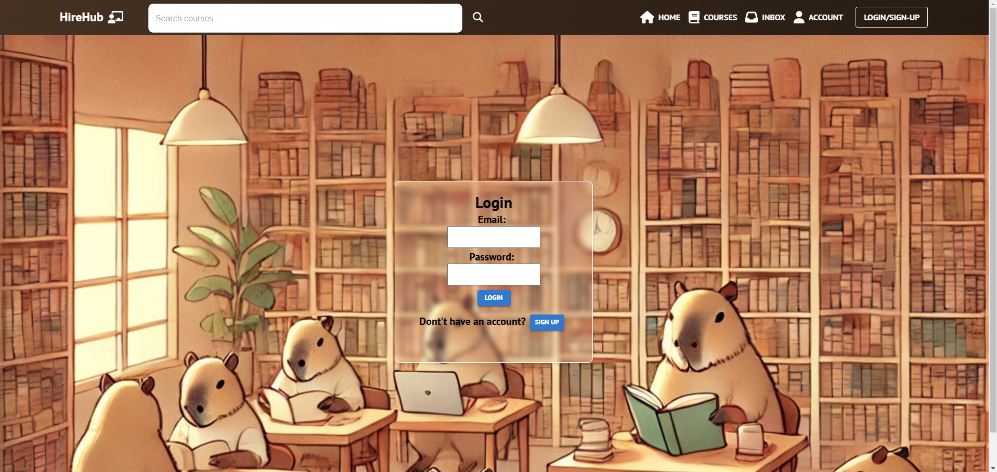

* + Enter your credentials:
    - Email: baoyijie111@gmail.com
    - Password: 123456
  + Click **Login**. If successful, you will be redirected to the Home page.

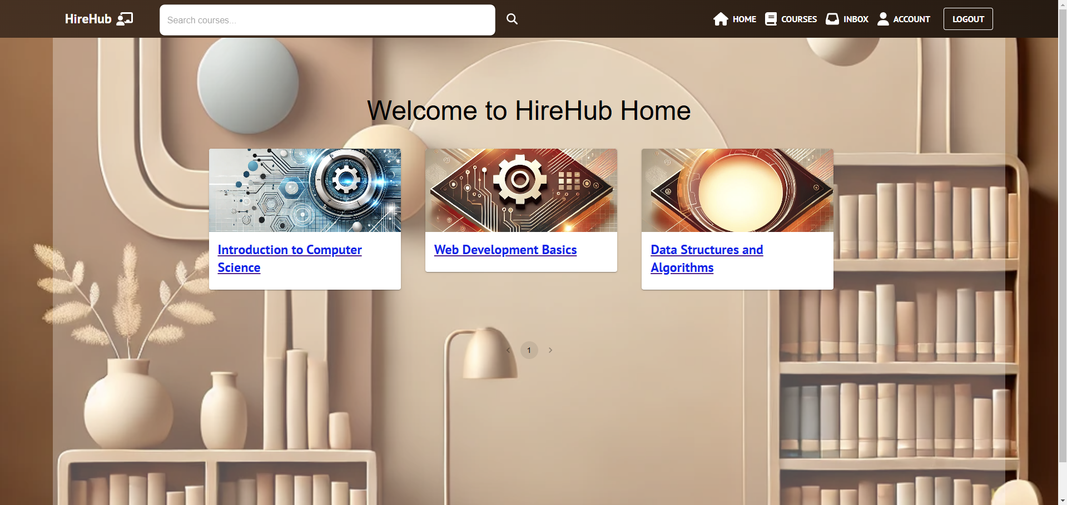

1. **Register**:
   * If you don’t have an account, click **SIGN UP** on the login page and fill in the required details.

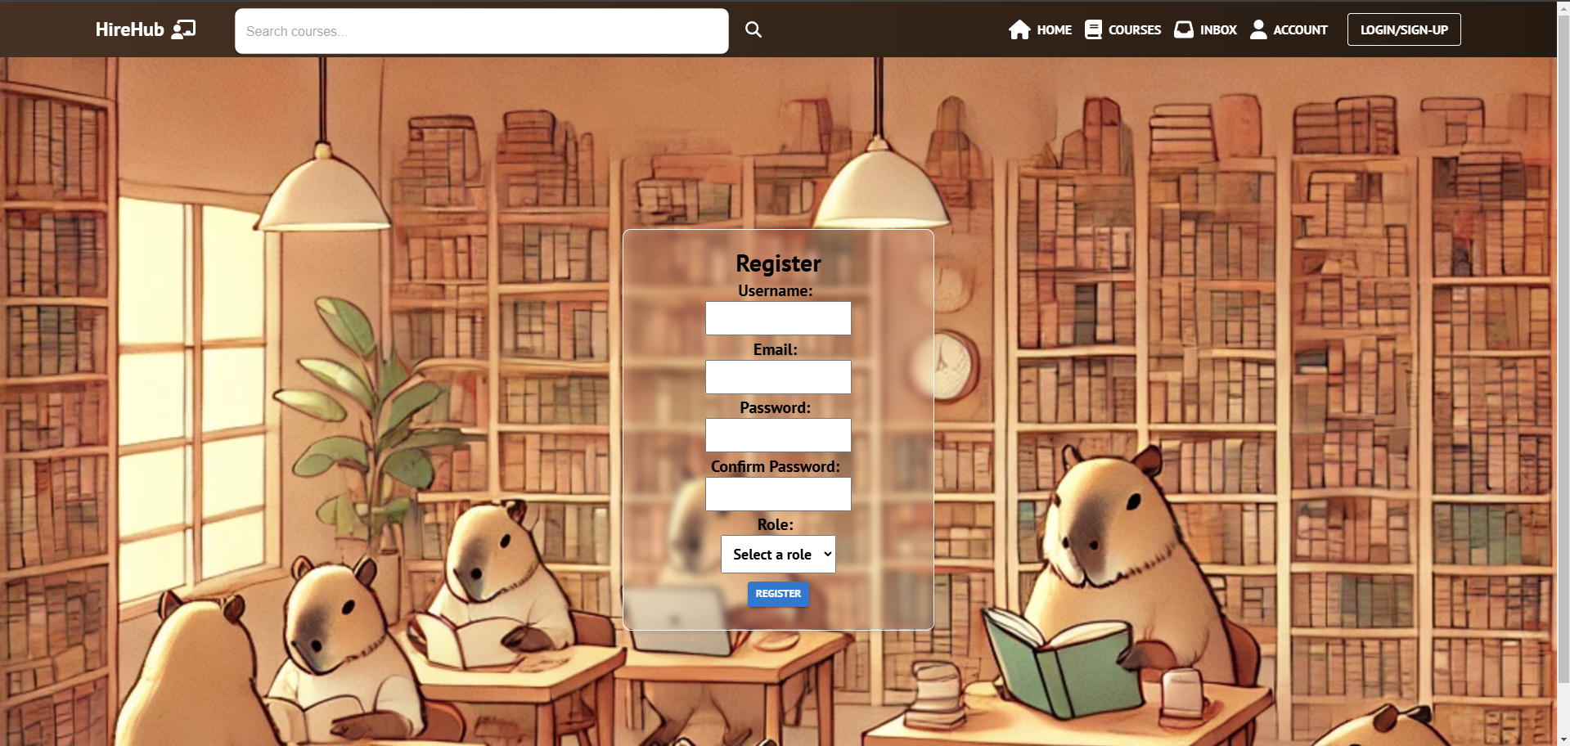

### **Key Features for Students**

1. **Home Page**:
   * View all courses you are enrolled in.
   * Click on a course to access its details.
2. **Course Page**:
   * Access specific course information and comments.
   * View videos, assessments, discussion forums, and feedback (static content except for videos).
   * **Enroll**: Click the **ENROLL NOW!** button to join a course. Enrolled courses unlock full content, including videos and assessments.

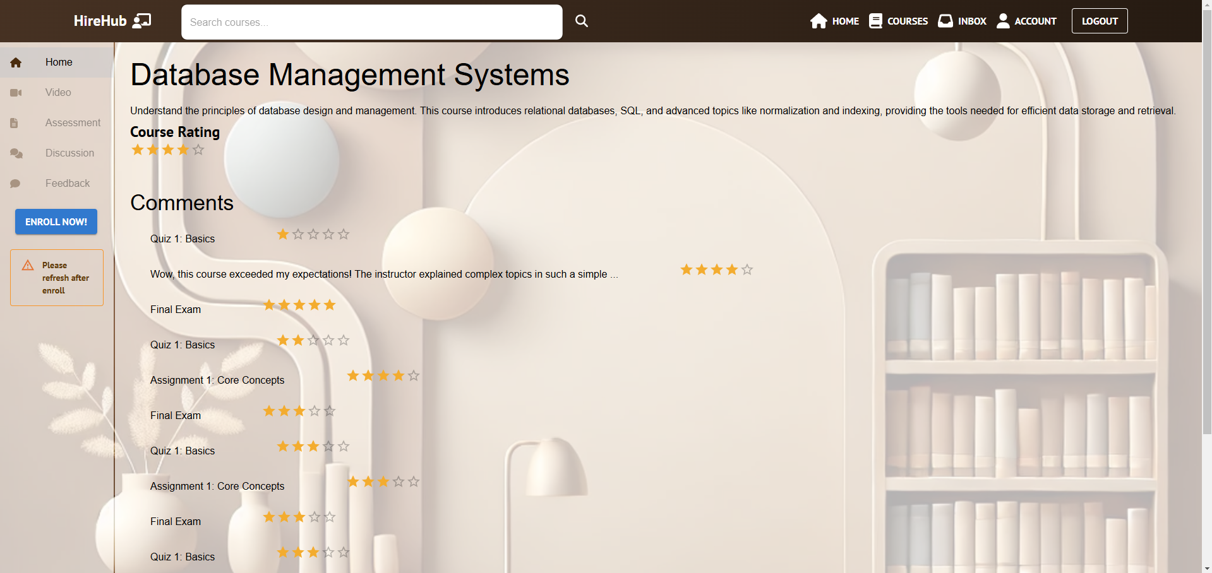

1. **Video List**:
   * Navigate to the **Video** tab in the left menu to access the approved videos for the course.
   * Click on a video to watch it.

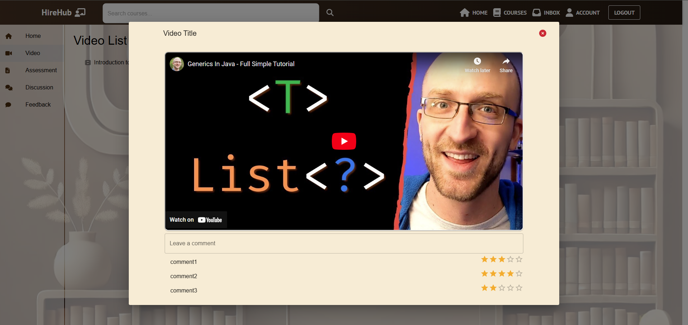

1. **Inbox**:
   * Click **Inbox** in the navbar to view messages you’ve received.
   * Compose a message by clicking the **Compose** button in the Inbox.

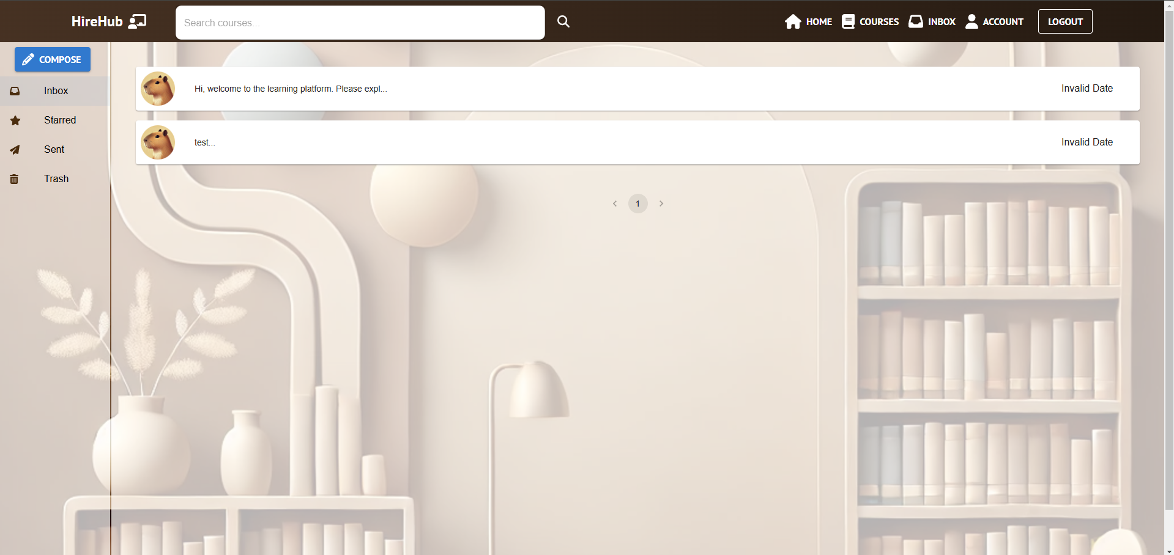

1. **Search Bar**:
   * Use the search bar in the navbar to search for courses by keywords. Results appear on the **SearchResult** page.
   * Click a course in the results to view its details.

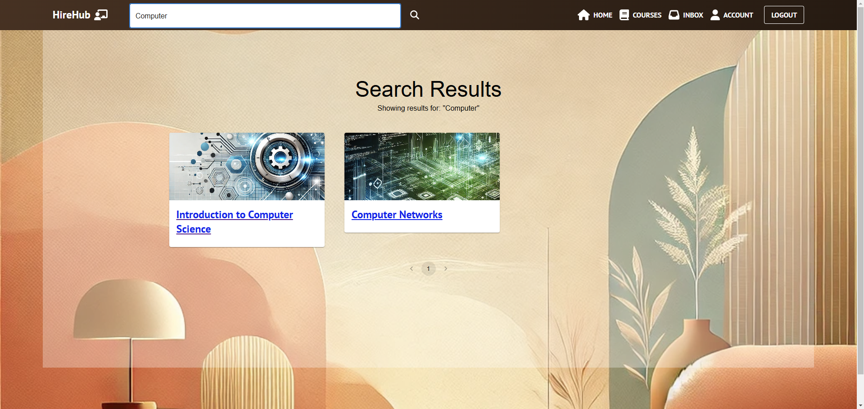

## **Instructor Manual**

### **System Purpose for Instructors**

As an instructor, you can:

* Teach and manage courses.
* Upload course materials, such as videos.
* Communicate with students and oversee course discussions.

### **Getting Started**

1. **Log in**:
   * Navigate to the login page.
   * Enter your credentials:
     + Email: instructor1@example.com
     + Password: instructor123
   * Click **Login**.



### **Key Features for Instructors**

1. **Home Page**:
   * View all courses you are teaching or have enrolled in.
   * Click on a course to access its details.
2. **Course Page**:
   * **Edit Course Information**: Click the **Edit** button next to the course title to update course details.

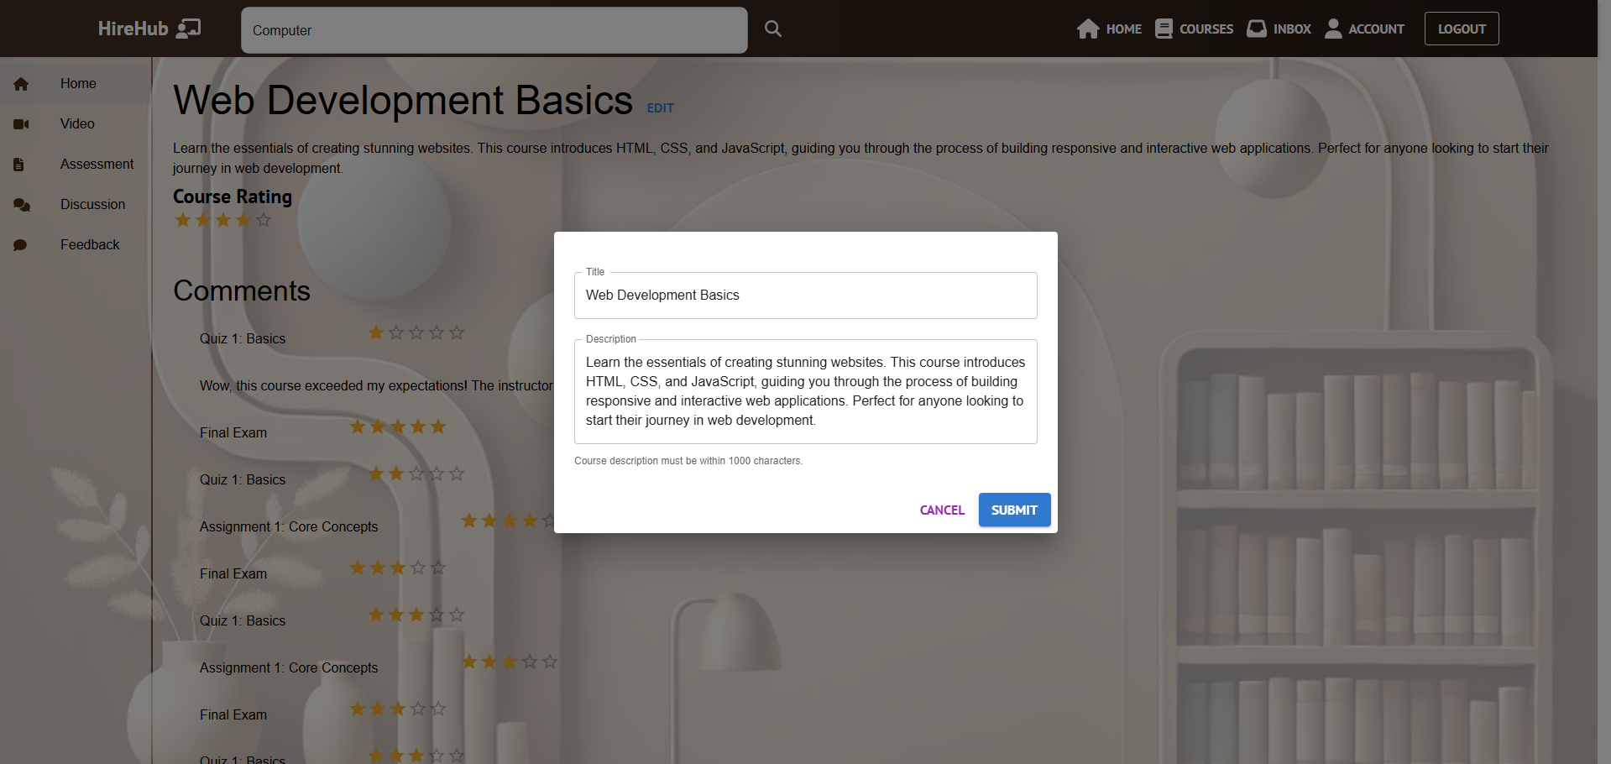

* + Access videos, assessments, discussions, and feedback in the left menu.
  + **Add Video**: Use the **Add Video** button to upload a new video (popup window).

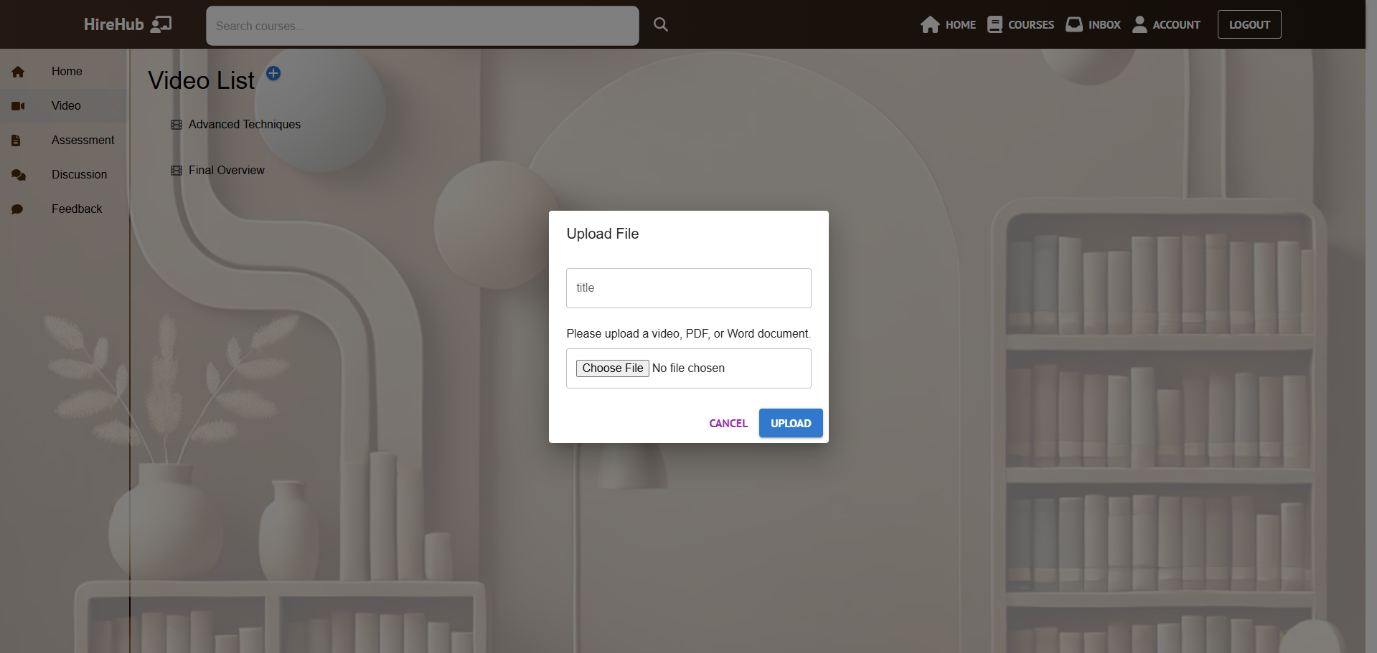

* + View the status of videos (approved or pending).

1. **Inbox**:
   * Access messages via the **Inbox** in the navbar.
   * Compose a new message by clicking the **Compose** button.

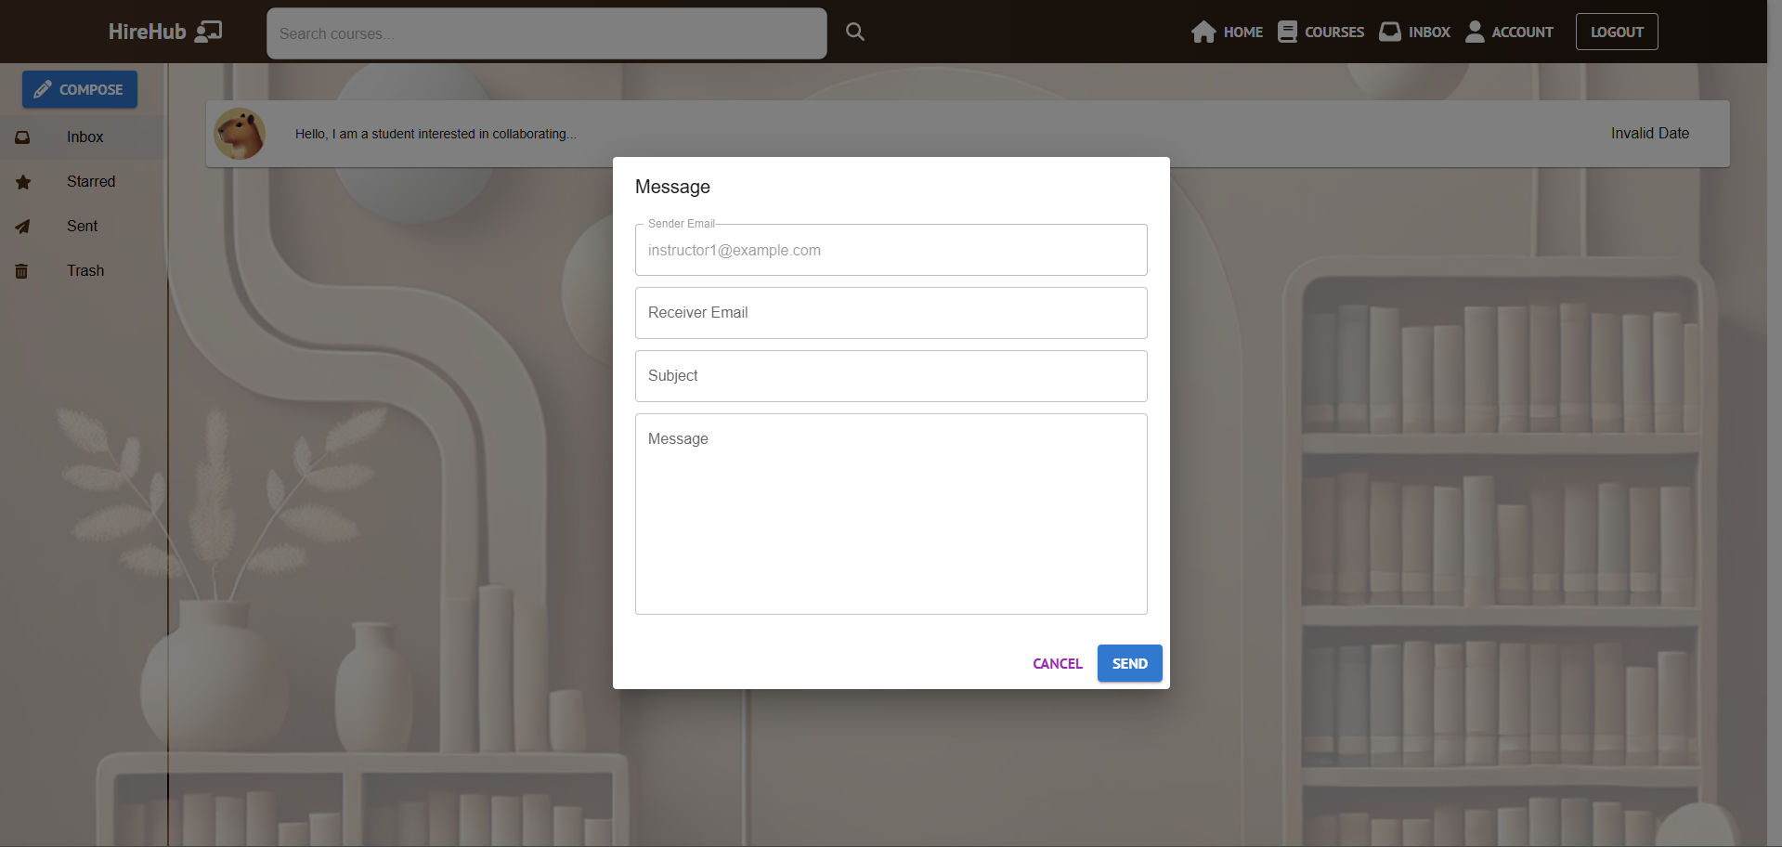

1. **Search Bar**:
   * Use the search bar to find courses by keywords. Results appear on the **SearchResult** page.
   * Click on a course to view its details.

## **Admin Manual**

### **System Purpose for Admins**

As an admin, you can:

* Oversee and manage all platform content.
* Approve or reject uploaded videos.
* Create new courses and monitor user interactions.

### **Getting Started**

1. **Log in**:
   * Navigate to the login page.
   * Enter your credentials:
     + Email: admin1@example.com
     + Password: admin123
   * Click **Login**.

### **Key Features for Admins**

1. **Home Page**:
   * View a list of all courses available on the platform.

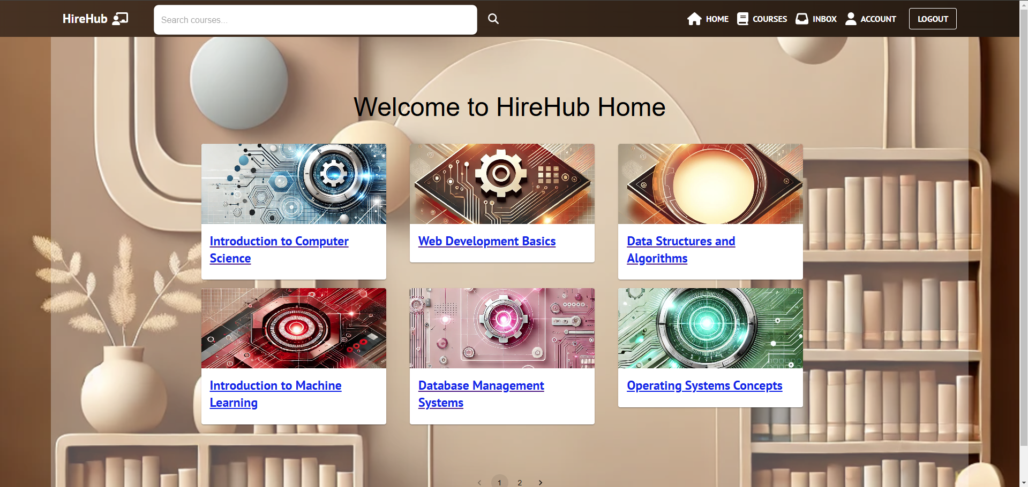

1. **Course Page**:
   * Access course details and manage content.
   * View and manage comments.
   * Monitor video statuses (pending or approved).

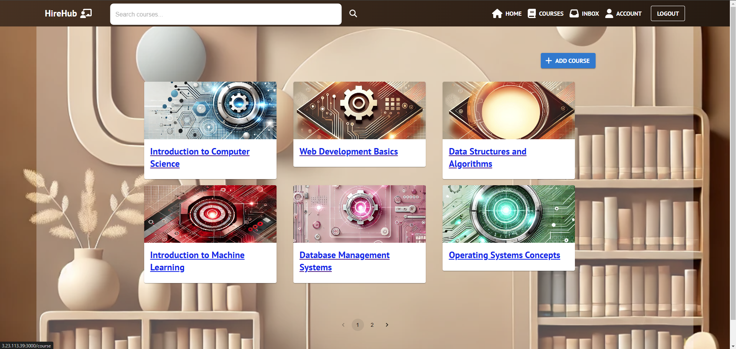

1. **Add Course**:
   * Click the **Add Course** button (available on the **Course** page) to create a new course using a popup form.

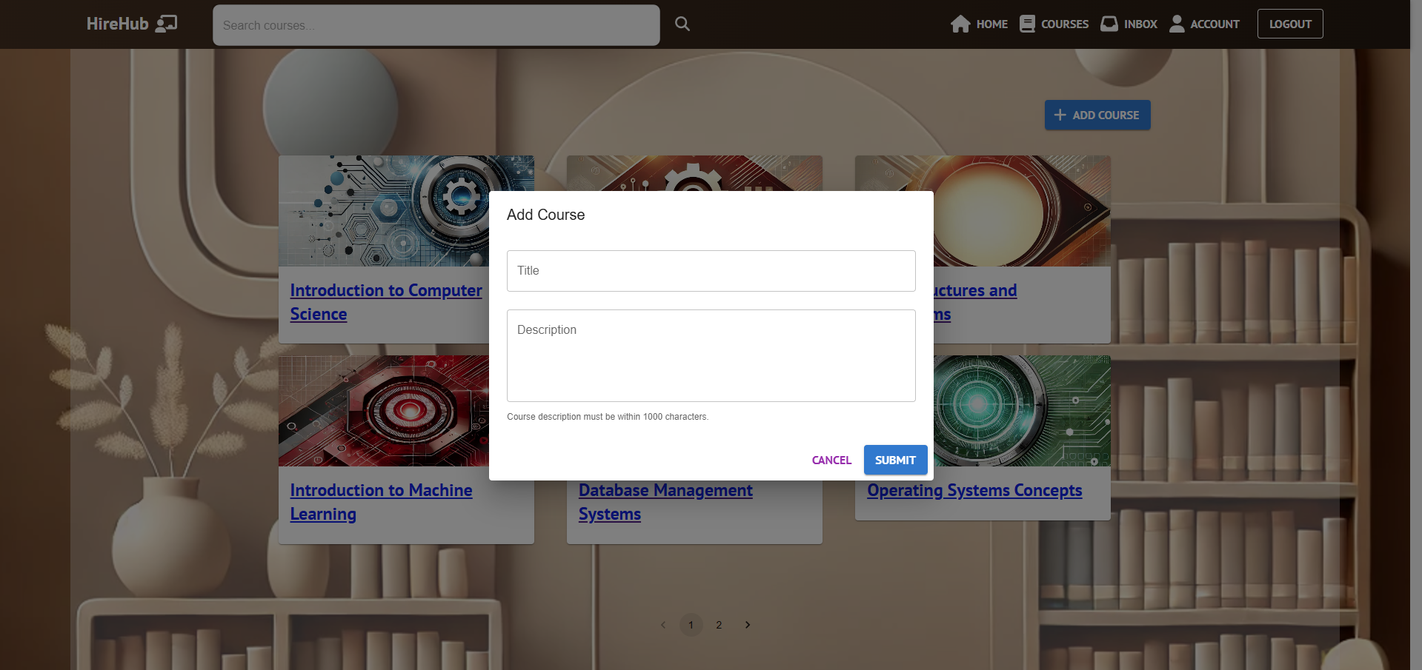

1. **Video Management**:
   * Access the **Video List** on the **Course Page** or through a dedicated admin dashboard.
   * View videos with **Pending** status.
   * **Approve or Reject Videos**:
     1. Approve suitable videos to make them available to students and instructors.
     2. Reject videos that do not meet the platform’s standards, with an option to provide feedback to the uploader.

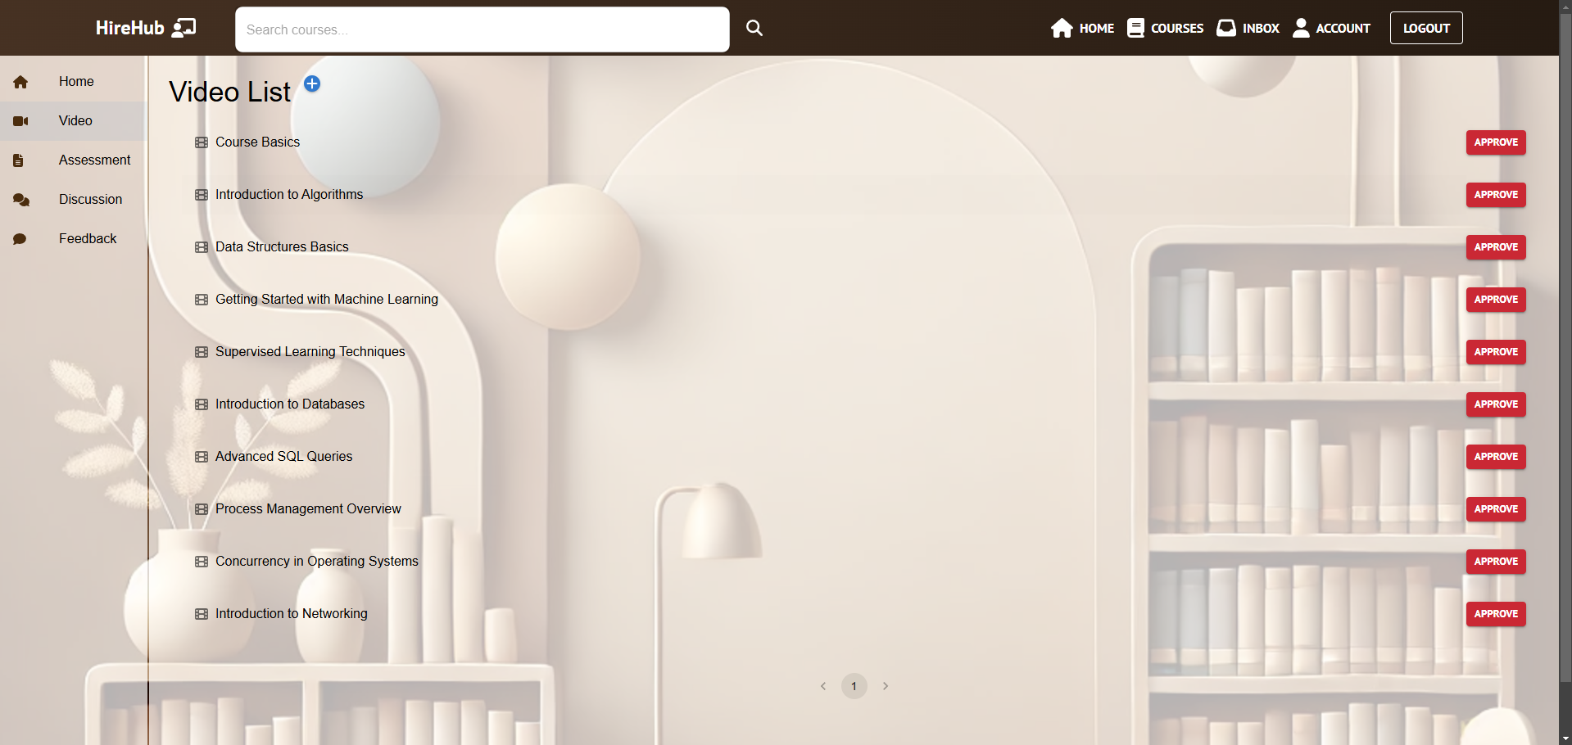

1. **Assessment Management**
   * **Access Assessments:**
     1. Navigate to the Course Page for a specific course.
     2. View assessments under the Assessments tab.
   * **Add a New Assessment:**
     1. Click the Add Assessment button (popup window).
     2. Fill out the form with:
        1. Title: Name of the assessment.
        2. File: Detailed instructions or information about the assessment.

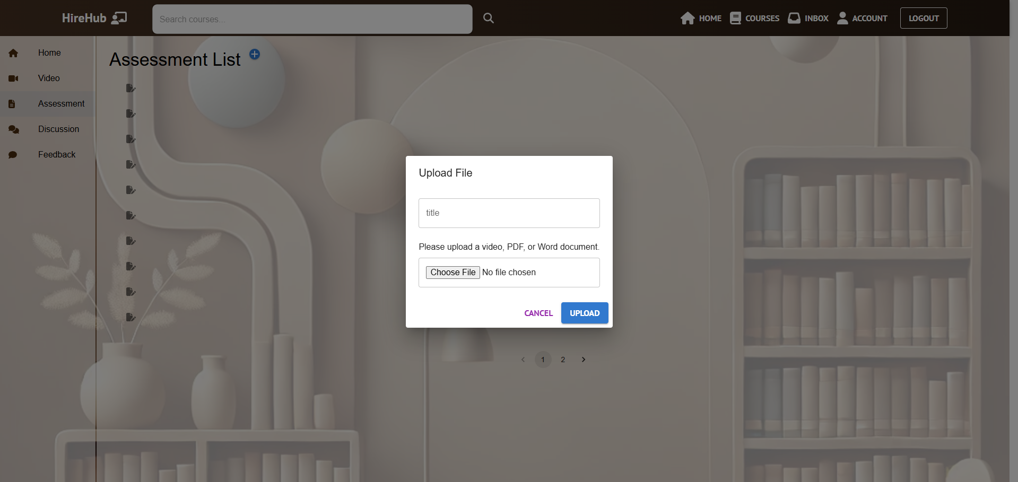

1. **Inbox and Messaging**:
   * Access **Inbox** to view messages received by the admin account.
   * Compose and send messages to specific users or broadcast announcements to all users.

